Milestone 1

Milestone 2

Server:

Client

Mile Stone 3

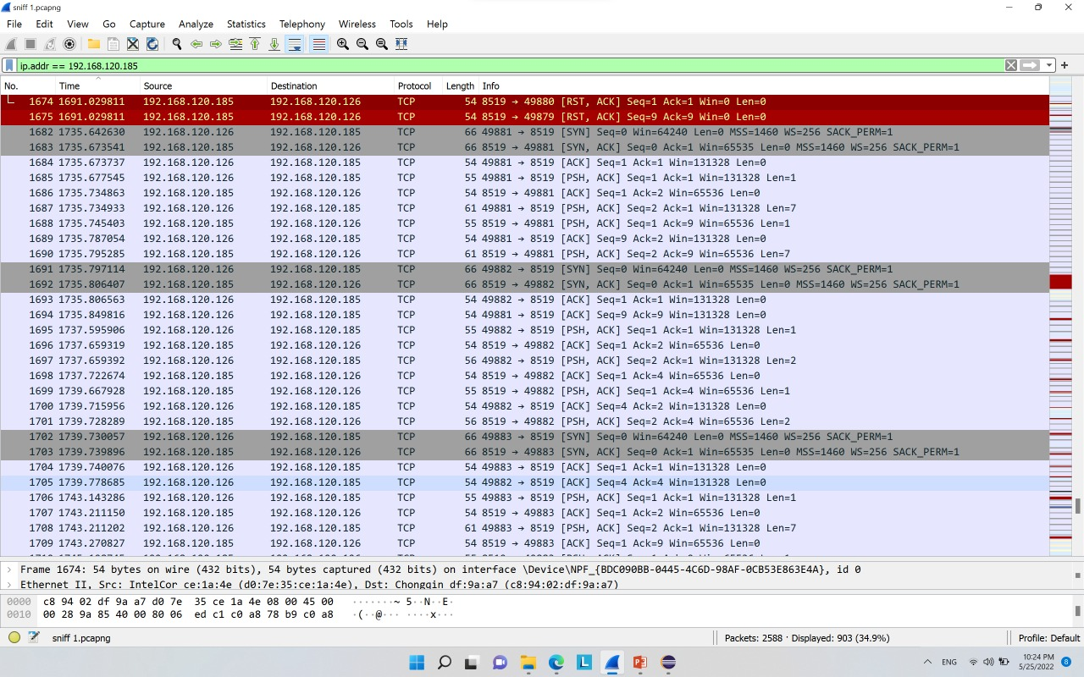

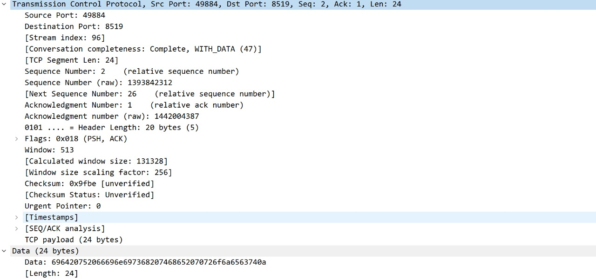

­­­­­­­

­­­­­­­­­Video Simulation

Server:



Client:

